|  |  |  |  |  |
| --- | --- | --- | --- | --- |
| **Name** | **Date** | **Reason for Change** | **Version** | **Approver** |
| Simon Leung | 01-Feb-2018 | Initial Document | 1.0 | Denis Luk, Simon Leung, Helen Ng |
| Simon Leung | 27-Apr-2025 | Enhancement add screen layout and function details | 1.1 | Simon Leung, Neville Leung, Helen Ng |
|  |  |  |  |  |

Revision History

# Purpose and Scope

The existing ICS Dialing System is developed by Visual FoxPro 9 and Delphi 5 run under Windows environment which were over their EOL support. It is required by management to rewrite the whole application using a new application language which having support and patch available.

# System Overview

The current system was divided into 5 sub-systems: Data Entry System, Admin System, Dunning System, Auto Dialing Server, and Daily Routine. When cases are assigned by the clients, it will input into Data Entry System first and assign the client code and collector to each case. Then the Data Entry System will upload the data to the server. Admin clerks will use Admin System to handle daily routines like payment input, recall cases, retain cases, hold the cases, print out reports, and print out letters for mail and visit. Collectors will mainly use the Dunning System for the daily operation to record the results of a phone call, the results of a site visit, and remind actions. The Dunning System has an external interface to connect with the in-house PABX system for auto dial-out. The Daily Routine system will run by the system automatically daily to update the status and batch routines like transfer collector, checking of client request return cases, checking missing dunning case, generating weekly and monthly reports for some clients, etc. The detailed workflow can refer to as “Flow Chart.PDF”.

## Basic requirements

* The applications should run on intranet only on the Window platform, all the data should store on the server-side, and no customer data will store at the local workstation (temporary files, cookies).
* The sensitive data (NAME, ID, ACNO … etc.) should be encrypted with the AES 256bit algorithm on the database.
* The new programming language and database should have official support and maintenance which will provide vulnerabilities fixing patch contingency.
* The application should provide a shortcut key for input and selecting data because most of the staff use the keyboard for input mainly.
* The response time for loading data should tune-up as quickly as possible.
* User authorization and authentication controls.
* Audit logs for CRUD.
* A penetration testing report of the release applications may request.
* It needs to provide all documents and source code of the applications after the end of the project.

## Points of Contact

|  |  |  |  |
| --- | --- | --- | --- |
| Project Manager | Simon | [simon@icshk.com](mailto:simon@icshk.com) | 21857727 |
| Programmer | Gary |  |  |
| Programmer | Johnny |  |  |
| Product Owner | Calvin | calvin.kwan@icshk.com |  |

# SYSTEM ARCHITECTURE

## System Hardware Architecture

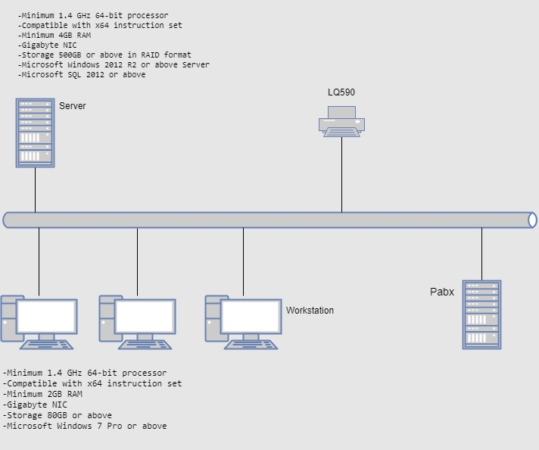

## System Software Architecture

Administration System

Dialing System

Daily Routine System

## Inter-Communication Architecture

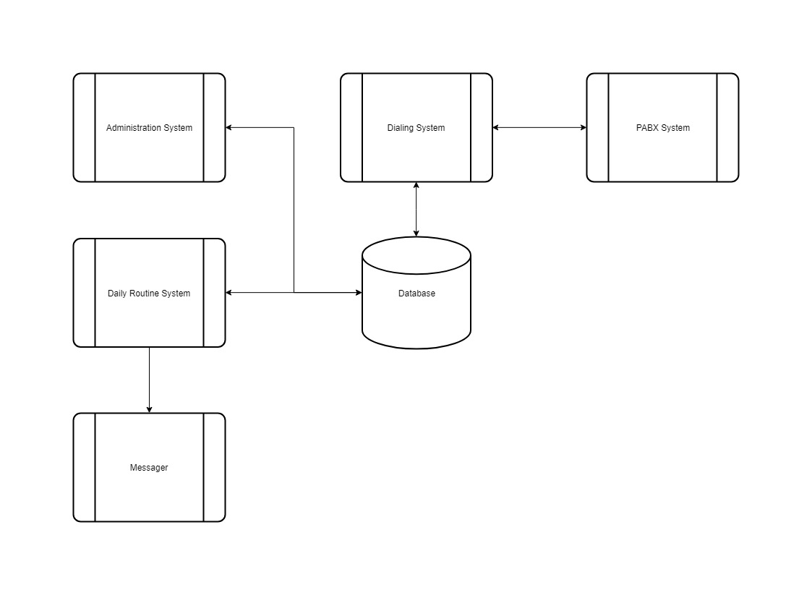

# Function Requirements

## Administration System

### Case Master

#### Case Enquiry

* Function to search accounts in the system
* Modify the data of accounts in the system
* Show all account-related information in the system like
  + Link/Package accounts
  + Payment history
  + Account assign date, amount, outstanding, debtor information, collector, client
  + Address/Phone books
  + Transfer history

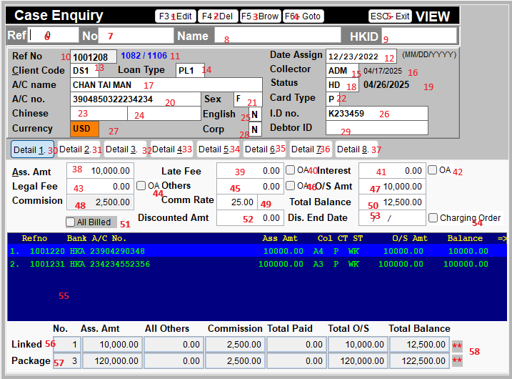

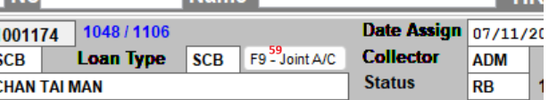

1: Entry edit mode

2. Delete current record

3. List all records

4. Go to linked/package account

5. Exit

6. Search by Refno

7. Search by A/C (full a/c, partial a/c 1111*4444, last 4 digit)

8. Search by Name (full name, partial CHAN * MAN)

9. Search by HKID/DebtorID (full id, partial id K124*)

10. Unique system generated refno with new case assigned

11. current record / total record

12. Case assigned date

13. Client code (each client will assigned one/multiple code, e.g 1st hand, 2nd hand …)

14. Loan Type (each client will have multiple product, e.g card/loan/mortgage..)

15. Collector code (current assigned collector)

16. Transfer date (some product set to transfer to another collector after a period)

17. A/C holder name

18. Case Status

19. Hold Date/Return Date/Settle Date (depend on the status of hold/return/settle)

20. A/C number

21. Gender

22. Card type (principle/sub-card)

23. Client provided Chinese name

24. Debtor provided Chinese name

25. English case

26. ID/Passport number/BR

27. Currency

28. Corporate account

29. Debtor ID (some client may provide tokenized ID replace the real Identity Card number)

30-37. Detail page for different information

**DETAIL 1 ASSIGNMENT INFO**

38. Assign amount

39. Late fee

40. Late fee need to count OA fee

41. Interest

42. Interest need to count OA fee

43. Legal fee

44. Legal fee need to count OA fee

45. Others fee

46. Others fee need to count OA fee

47. Total outstanding amount (exclude OA fee)

48. Commission (OA fee)

49. Commission Rate (OA fee rate for debtor)

50. Total balance (include OA fee)

51. Flag for all billed ()

52. Discounted amount if can full pay before discount date

53. Discounted amount period

54. Account has charging order

55. Linked/Package list. (Linked: same debtor’s accounts under same client / sub-card; Package: same debtor’s accounts under different clients)

(refno, client code, a/c number, assign amount, collector, card type, status, o/s amount, balance, others fee (sum of late fee, interest, legal, other), commission) [view by CTRL+PU/PD]

56. Summary of linked accounts

57. Summary of package accounts

58. Mark for accounts contains other currency

59. Join accounts info. 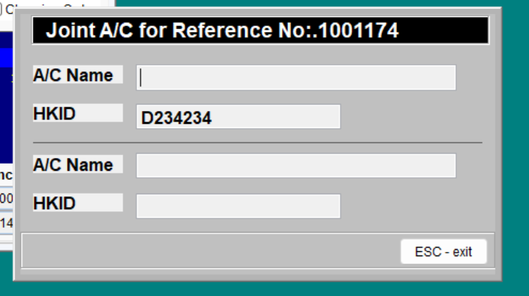

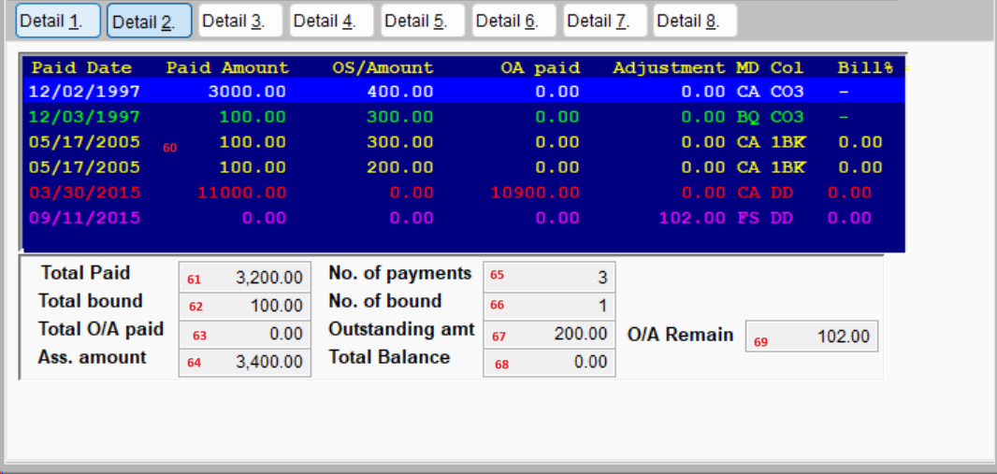

**DETAIL 2 PAYMENT INFO**

60. Payment history (Pay date, pay amount, o/s amount after payment, oa paid, adjustment, payment method (CA-cash/pps…; BQ-bound cheque; BB-adjust by bank; BA-adjust by agent; FS-force settled), collectors (payment collected by which collector, may include visitor for some client), Bill rate, Payment cycle, debit note number, collector commission note number, payment received from client, write off payment, transaction ID, Payment Type, SCB Type, Payment Source) [view by CTRL+PU/PD]

61. Total paid

62. Total amount bound (invalid payment)

63. Total OA paid

64. Assign amount

65. No. of payments

66. No. of bound payment

67. Current outstanding amount

68. Current balance

69. OA remain

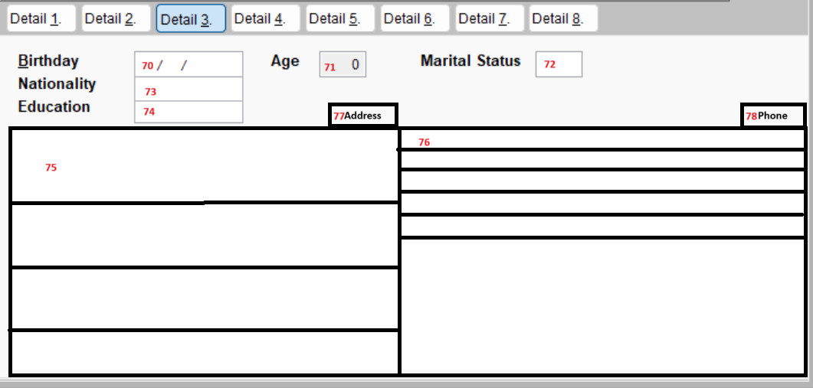

**DETAIL 3 DEBTOR PERSONAL INFO**

70. Birthday

71. Age

72. Marital status

73. Nationality

74. Education

75. Personal Address list

76. Personal Phone list

77. Add/Edit personal address

78. Add/Edit personal phone

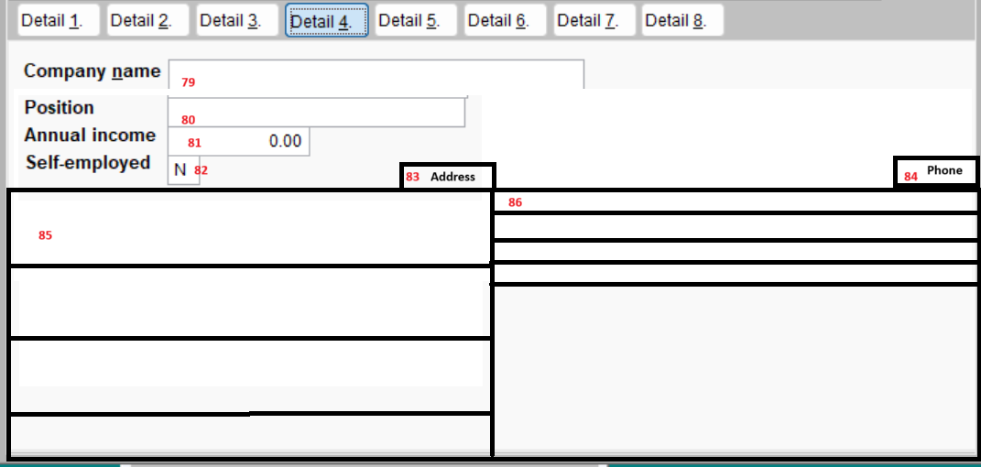

79. Company name

80. Position

81. Annual income

82. Self-employed

83. Add/Edit company address

84. Add/Edit company phone

85. Company address list

86. Company phone list

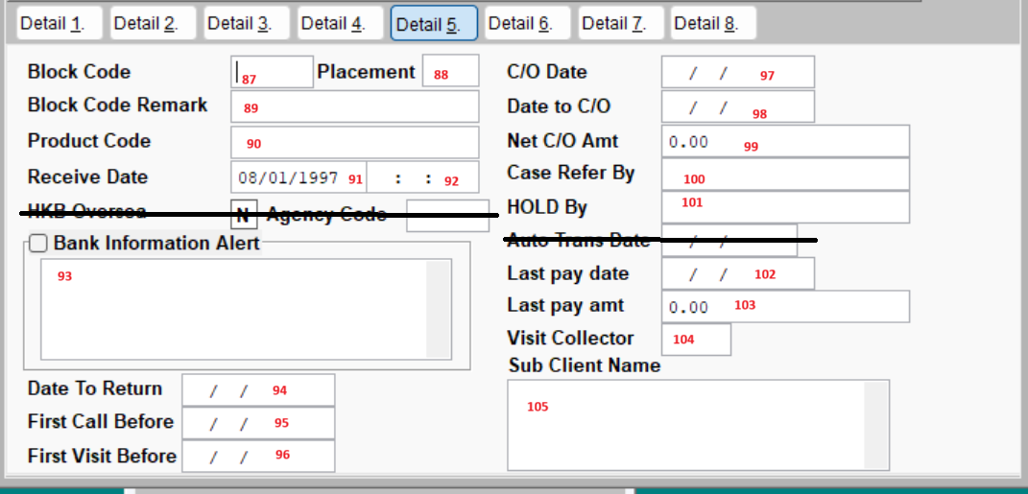

**DETAIL 5 Additional assignment info**

87. Block Code

88. Placement (number of DCA assigned)

89. Blockcode remark / location code (CIT)

90. Product Code

91. Receive Date (case received/inputted into system)

92. Receive Time (case received/inputted into system)

93. Bank provided comment/alert info

94. Date to recall/return to client

95. First call before (need first call before the date)

96. First visit before (need first visit before the date if no payment/ptp)

97. C/O date (charge off date)

98. Date to C/O (date will become charge off account)

99. Charge off amount

100. Case refer by (private case)

101. HOLD By (case hold request by)

102. Last payment date (provided by client)

103. Last payment amount (provided by client)

104. Visit collector code (1st visit by collector for phone clerk cases, will have 10% commission)

105. Sub-client name (additional name for client)

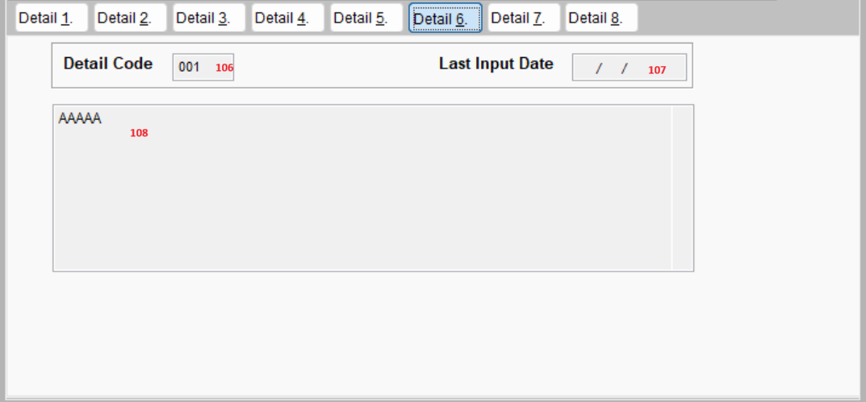

**DETAIL 6 Case Status Details**

106. Predefined code for case status use in report

107.Detail code update date

108. Detail code details

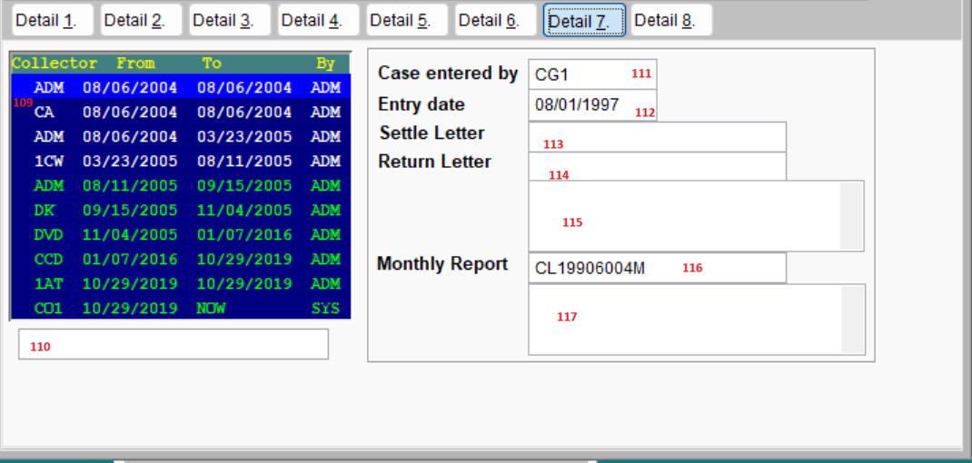

**DETAIL 7 Transfer history & case report info**

109. Case transfer history

110. Client refno info (additional product info)

111. Case entered by

112. Case entry date

113. Settle letter number

114. Return letter number

115. Return reason

116. Last monthly report number

117. Last HOLD reason

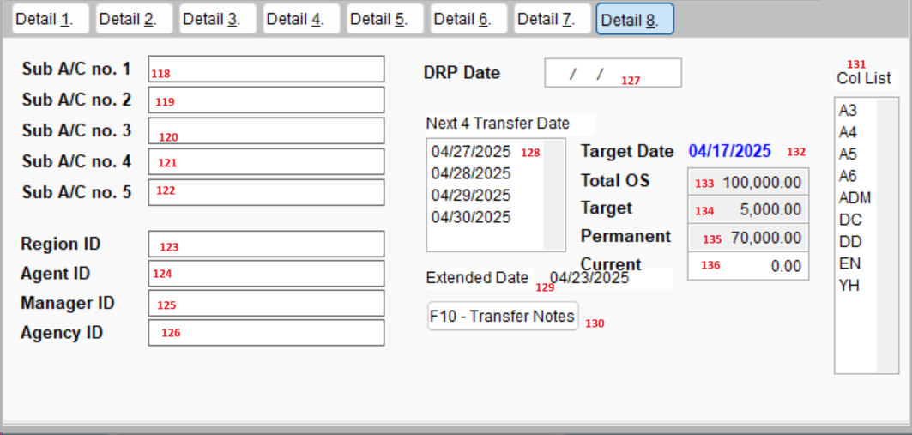

**DETAIL 8 Additional account info & auto transfer info**

118 - 122. Additional account number

123. Region ID (BLO)

124. Agent ID (BLO)

125. Manager ID (BLO)

126. Agency ID (BLO)

127. DRP Date

128. Next 4 auto transfer date

129. Auto transfer extend date

130. Auto transfer Notes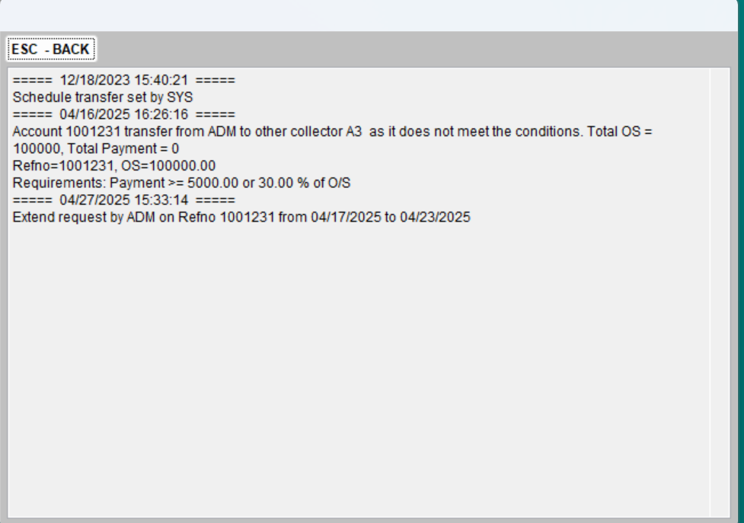

131. Auto transfer collector list

132. Auto transfer date

133. Total OS of linked accounts

134. Target to meet for retain transfer

135. Permanent to meet to stop auto transfer

136. Current payment in the transfer period

***Short-Cut key***

#### Case Entry

##### Case Entry

* Function to input cases received from the client into the system
* Mapping of different types of import files (Excel, Text, CSV)
* Auto-assign client code, loan type, collector to each case base on the setting set by the supervisor

##### Case Entry Report

* Print out case entry summary (PRINT)

##### Case Data Update

* Function to update case information by importing Excel file

##### Change Client Code

* Function to update case client code in case of wrong input

#### Case Transfer

##### Case Transfer One by One

* Case transfer from one collector to another by manual entry

##### Case Transfer by Batch

* Case transfer by selecting criteria

##### Period Transfer Setting

* Auto transfer case periodically set by supervisor

##### Case Transfer Report

* Print out case transfer report (PRINT)

#### Case Return

##### Process Case Return

* Update case status to return status by manual or batch input

##### Print Return Letter

* Print out unprocessed return notice to client (PRINT/EXPORT/SELECT FIELDS)

##### Print Processed Return Letter

* Re-print processed return notice to client (PRINT/EXPORT/SELECT FIELDS)

#### Case Settle

##### Print Settle Letter

* Print out unprocessed settle notice to client (PRINT/EXPORT/SELECT FIELDS)

##### Print Processed Settle Letter

* Re-print processed settled notice to client (PRINT/EXPORT/SELECT FIELDS)

#### Case Detail Code

##### Case Detail Code Maintenance

* Setup unique code represents the different status of the account used in the report

##### Detail Code Entry

* Update account status detail code manually

##### Auto Detail Code

* Update account status detail code automatically using criteria set by the supervisor

#### Hold Case

##### Hold Case by Batch

* Change account status to HOLD, such that the collector cannot take actions on the HOLD accounts

##### Held Case Recall Date Report

* Report for HOLD case recall date (PRINT)

#### User Case Report

* Function to allow the user to export case-related information (EXPORT)

#### Past Due Entry

* Function to update account past due history

#### Case Address Batch

##### Address/Phone Entry

* Function to import address/phone provided by the client

##### Update Address Status

* Function to check the existing address and update address status with the imported file

##### Invalid Phone Checking

* Function to check existing phone with invalid mark compared with the imported file

##### Invalid Address Mapping

* Function to compare two files containing an invalid address

##### Export Address/Phone

* Function to export address/phone (EXPORT)

##### New Address/Phone Checking

* Compare with imported file to find new address / phone

#### Print Visit/Mail Letter

##### Print Letter

* Print letter order by a collector for MAIL or VISIT (PRINT)

##### Print Label

* Print label for VISIT (PRINT/EXPORT)

##### Print 1st Letter

* Print 1st Letter for the special client (PRINT)

##### Visit District Report

* Report of district visit statistic (PRINT)

##### Mail Statistic Report

* Report of MAIL statistic (PRINT)

##### Upload VISIT result

* Upload visit result import by collector

##### Undelivered Letter

* Input record of undelivered letter of accounts

##### Unsuccessful Visit

* Check unsuccessful visit using keyword

#### Retain Case

##### Retain Case flow

* The flow of retain/return case
  + Import account request by the client for return
    - Send a message to the collector to input retain/return
  + Process retains for retain requests by collector
  + Process returns for return requests by collector
  + Processed batch records

##### Retain Case Report By Action

* Print out retain account by action code enter by collector (PRINT/EXPORT/SELECT FIELDS)

##### Request to Retain Case Report

* Export request to retain case report for client with retain reason input by collector (PRINT/EXPORT/SELECT FIELDS)

#### Action Code Details

* Print/Export account information by action code entered in Dialing System (PRINT/EXPORT/SELECT FIELDS)

#### Reopen Cases

* Reopen Returned Case by batch

#### Case Expiry Master

* Update expiry date/need to return date of accounts

#### Add Dunning

* Upload dunning records by the batch import

### Payment Master

#### Payment Entry

* Update payment history of accounts provided by clients

#### Payment Edit

* Update payment record manually

#### Daily Payment Confirmation

* Print/Export payment confirmation request to client (PRINT/EXPORT)

#### Balance Update

* Update accounts outstanding or balance by batch

#### Payment Check

* Print out payment entry record for verification (PRINT/EXPORT)

#### Update Billrate

* Update special bill rate by import batch

### Client Master

#### Client Maintenance

* Maintenance client information

#### Online User Master

* Maintenance of client user right for access Dialing System in audit

#### Letter Header/Footer Master

* Maintenance letter header/footer template for client reports

#### Additional Contact

* Maintenance of additional contact information for the client

### Collector Master

#### Collector assignment setting

* Setup collector assignment criteria for the case

#### Collector Payment History

* Show the collector payment history

#### Commission Scheme

* Setup collector commission template

#### Traffic Fee

* Input/Approve traffic fee for collector/courier

### Report Master

#### Monthly Report

##### Monthly Report (PRINT/EXPORT/SELECT FIELDS)

##### Reprint Processed Report

#### Case Report

##### Case Report (PRINT/EXPORT/SELECT FIELDS)

##### Inventory Report (PRINT/EXPORT/SELECT FIELDS)

#### Payment Report

##### Payment Statistic Report (PRINT/EXPORT)

##### Payment Report (PRINT/EXPORT/SELECT FIELDS)

##### Collector Payment Statistic Report (PRINT/EXPORT/SELECT FIELDS)

##### Collection Point Report (PRINT)

##### Commission Statistic Report (EXPORT)

##### Payment Breakdown Report (EXPORT)

##### Last Payment Report (PRINT)

#### Case Statistic Report

##### Case Statistic Report (PRINT)

##### Case Assigned Report (PRINT)

##### Case Bankruptcy/IVA/DRP Statistic (EXPORT)

##### Monthly Agnecy Report (EXPORT)

##### Case Inventory Statistic Report (EXPORT)

#### Dunning Report

##### Dunning Report (PRINT/EXPORT/SELECT FIELDS)

##### Telephone and Dunning Record (PRINT/EXPORT)

##### Auto Dial Report

###### Auto Dial Call Login Log (PRINT)

###### Auto Dial Logon statistic (PRINT)

###### Auto Dial Call Out Log (PRINT/EXPORT)

###### Auto Dial Action Statistic (PRINT)

###### Auto Dial Case Static (PRINT)

###### Auto Dial Queue (PRINT)

##### Dunning Report (EXPORT)

#### Performance Report

##### Performance Analysis Report (PRINT)

##### Collector Recovery Performance and Collection Forecast Report (PRINT/EXPORT)

##### Collection Forecast Report (PRINT/EXPORT)

##### Monthly Performance Report (PRINT)

##### Collector Spin-down Report (PRINT/EXPORT)

##### Same Period Performance Report (PRINT/EXPORT)

##### Monthly Statistical Summary Report (EXPORT)

##### Collector Contribution Report (PRINT)

##### Collector Competition Report (EXPORT)

#### Productivity Report

##### No. Of Call Report (PRINT)

##### No. Of Call By Action Code Report (PRINT)

##### Action Code with Narrative Report (PRINT/EXPORT)

##### Collector Queue Report (PRINT)

##### Work Down Report (PRINT)

##### Case Contact Report (EXPORT)

##### Lost Contact Report (PRINT/EXPORT)

##### Bucket Report (PRINT/EXPORT)

##### BackLog Statistic Report (PRINT)

##### Visit Statistic Report (EXPORT)

##### Visit Statistic Report By Collector and District (EXPORT)

##### No Actions Report

#### PTP Report

##### PTP Report (PRINT/EXPORT/SELECT FIELDS)

##### PTP Report for Clients (EXPORT)

#### Spin-Down Report

##### Spin-Down Report (PRINT/EXPORT)

##### Spin-Down Details (PRINT)

##### Spin-Down (PTP Forecast) (EXPORT)

##### Spin-Down (Recovery by Batch) (EXPORT) (PRINT)

##### Batch Spin-Down (PRINT)

##### Performance Spin-Down (PRINT)

#### Audit Report

##### Report Export Log (PRINT)

##### Case Access Log (PRINT)

##### User Entitlement Report (PRINT)

##### User Rights Change Log (PRINT)

##### Verification Log (PRINT)

##### Login Log (PRINT)

##### Password Change History (PRINT)

#### Report For Clients

##### CIT Reports

###### CIT Export

###### CICK Report (EXPORT)

###### TU Address Report (EXPORT)

###### Return List (EXPORT)

###### Monthly Statistic Export (EXPORT)

###### CIT BCall

###### Check Warning Keywords

###### CIT Team Incentive

###### CIT Inentory with OA

##### ZAB Reports

###### ZAB Notice

###### ZAB Status Report

##### SCB Reports

###### Status Report (EXPORT)

###### Meeting Prepare Data (PRINT)

###### Monthly Case Review (EXPORT)

###### Dunning Export (EXPORT)

###### Performance Report

Performance Report (EXPORT)

Contact Review Report (EXPORT)

###### Autodial Performance Report (EXPORT)

###### Vist Report

###### DCA Report (EXPORT)

###### Invalid Address/Phone List (EXPORT)

###### TU Phone Check (EXPORT)

##### BLO Reports

###### Address Match (EXPORT)

###### BARF Report (EXPORT)

###### BSRF Report (EXPORT TEXT)

##### HSB Reports

###### Stauts For Large Outstanding Report (EXPORT)

###### Performance for Debt Collection Report (EXPORT)

###### Return Address (EXPORT)

###### OA Compare Report (EXPORT)

###### Weekly Recovery Rate Performance (EXPORT)

###### DCA Productivity Dashboard (EXPORT)

###### KPI Report (EXPORT)

###### Assignment Check

###### Daily Export (EXPORT)

##### HKB Reports

###### Daily Export (EXPORT TEXT)

###### Assignment Mapping (EXPORT)

###### Address/Phone Mapping (EXPORT)

###### DCA Report (EXPORT)

###### Inventory Report (EXPORT)

###### Hear Year/Year-End Report (EXPORT)

###### Branch Cost Centre Update

##### CCIG Reports

###### CCIT Notice

##### WHB Reports

###### Monthly Report (EXPORT)

### System Master

#### User Maintenance

* User account setup with user profile contains different authenticate to access all systems

#### System Setting

* System setting includes company profile, PTP criteria

#### Purge Log

* Print out purge log (PRINT PDF)

#### Auto Dial Setting

* Auto dial profile setting

#### System Action Setting

* Action code automatic generate setting

#### Highlight Words Setting

* Highlight word for address note

#### Privacy Update

* Privacy information update/rollback

#### System Setting

##### Password Policy Setting

* Password policy of the application

##### Export Review Setting

* Action code for export audio review

##### Generate Supervisor Code

* Supervisor code for dual control

##### Generate Print Code

* Print code for dual control

##### Tips Setting

* Show tips with conditions in dialing

#### Popup Maintenance

* Popup data maintenance (District, Gender, Area code … etc.)

#### Billing Master

##### Currency Maintenance

* Maintenance of currency rate provided by C01

##### Billing Sheets

* Print out the invoice for clients (PRINT/EXPORT/SELECT FIELDS)

##### Re-print Processed Billing Sheets

* Re-print processed billing sheets (PRINT/EXPORT/SELECT FIELDS)

##### SCB Invoice

* Special invoice for SCB (EXPORT)

##### SCP Pay List

* Special Pay List for SCB (EXPORT)

#### Salary Master

##### Collector Commission Sheets

* Print commission sheet for collector (PRINT)

##### Processed Collector Commission Sheets

* Re-print collector commission sheet (PRINT)

##### Team Head Commission

* Extract commission for Team Head

## Dialing System

### Basic Setting

#### Source Code Maintenance

#### Person Code Maintenance

#### Action Code Maintenance

#### Narrative Maintenance

#### Action Code Filtering

#### Review Master

#### Queue Setting

#### Holiday Maintenance

### Dunning Entry

#### Dunning History

#### Address Book

#### Phone Book

#### Promise To Pay History

#### Payment History

#### Account summary

### Account Search

### Review Queue

#### Self-Review

#### Team Head Review

#### Supervisor Review

#### No Payment Review

#### No Action Review

#### No Phone Review

#### Oversea Phone Review

#### Invalid Phone Review

#### TU Address Review

#### Update District Review

### VISIT Queue

### NEW Queue

### RECALL Queue

### BACKLOG Queue

### RETURN Queue

#### CRR Queue

#### OKRA Queue

### HOLD Queue

### BPTP Queue

### Payment History

### Payment Remind

### Auto Dial

## Daily Routine System

* Update PTP Status
* Update Queues
* Auto Transfer
* Remind Return
* Reminde action not meet requirements
* Update Accounts status
* Update Accounts Detail Code
* CIT Monthly Report
* HSB Weekly Report
* HSB Agency Report
* SCB Monthly Report
* BLO Weeking Report
* Purge Accounts
* Auto Dummy Actions (Duning/Visit/Mail)

# Glossary

|  |  |
| --- | --- |
| Action Code | Unique code use in dunning history remark the results. |
| Admin clerk | Admin staff at administration department, main duty is communication with client and handle assignment, payment, return and hold cases. |
| Auto Dialing | Auto dial out phone call by PABX system and response the result to Dialing system. |
| Backlog Queue | List of cases need to follow up and recall date is over working date |
| BPTP | Broken Promise To Pay |
| Case | Account assigned by clients |
| Case Transfer | Swap the account handler collector to different collector. |
| Client code | Unique code assigned for client/product |
| Client Group | Unique code use to group different client code of same organization |
| Collector | Staff of collection department, main duty is collect debt from debtors thought phone call, field visit. |
| CRR | Client Request Return |
| Force Settle | Account closed with partial payment and approved by client. |
| HOLD Case | Account in HOLD status will not do actions by collector |
| Linked accounts | Accounts of same debtor under same client group |
| Narrative | Detailed description for the action taken in dunning history. |
| NEW Queue | List of cases just arrived, case resume from HOLD status or other criteria set by supervisor |
| OKRA | OK To Return Requst by Agent |
| Package accounts | Accounts of same debtor under different client group |
| Person Code | Code represent Contact Person |
| PTP | Promise To Pay |
| Purge | Remove unnessary data from database |
| Recall Date | Next follow up date for the account |
| Recall Queue | List of cases need to follow up on working date |
| Refno | Unique number assigned to each account. |
| Return Case | Account recall by client or return by agent, close the case after return accepted by client. |
| Settle Case | Account with payment and settled, close the case after fully payment or force settle approved by client. |
| Source Code | Code represent Contact Source |